

Aviation Safety

Quality, Integration, & Executive Service

Information Technology Division

**Attention:** New and current Industry/FAA SDRS Account Holder/Submitters/Users:

Per Executive Order **14028**, Improving the Nation’s Cybersecurity, **dated 5/12/2021**, the **Service Difficulty Reporting System (SDRS)** is incorporating multi-factor authentication (MFA) OKTA Verify for all users who login to sdrs.faa.gov starting **12/20/2023.**

MFA is an important step toward combatting the persistent and increasingly sophisticated malicious cyber campaigns that threaten the public sector, the

private sector, and ultimately the American people’s security and privacy. MFA provides for a secure authentication and login process to access SDRS and other FAA systems.

Please carefully follow the scenarios below that meet your current situation as a new or existing SDRS account user.

After the transition, you will login to SDRS.faa.gov using OKTA Verify.

If you have any questions or issues regarding MFA or OKTA Verify, please contact the FAA My IT Helpdesk at (844) FAA-MYIT / (844) 322-6948 or [helpdesk@faa.gov](mailto:helpdesk@faa.gov).

**Multifactor Authentication – OKTA Registration and setup instruction**

SDRS – Service Difficulty Reporting System (SDRS)

**Contents**

1. Introduction 3

2. Part 2: MFA for SDRS External Users (Submitters) 4

**Scenario 2.1: New SDRS user not registered in OKTA and not authorized in SDRS.** 4

**2.1.1 Accessing SDRS** 4

**2.1.2** **Registering in OKTA** 6

**2.1.3 Activate OKTA Registration** 10

**2.1.4** **Setting up Authenticator.** 12

**2.1.5** **Installing OKTA on your mobile device.** 13

**2.1.6** **Registering in SDRS** 17

**2.1.7** **Admin User Approving Account** 18

**Scenario 2.2: User is authenticated in OKTA and registered in SDRS, accessing SDRS.** 19

**2.2.1** **Accessing SDRS** 19

**2.2.2** **Validate using an authenticator.** 21

**2.2.3** **Landing Page view upon Validation** 23

**Scenario 2.3: Existing SDRS User Registering in OKTA and accessing SDRS** 23

**2.3.1** **Accessing SDRS** 23

**2.3.2 Registering in OKTA** 25

**2.3.3 Activate OKTA Registration** 29

**2.3.4** **Validating using Authenticator.** 31

# Introduction

The FAA IT team is implementing Multi Factor Authentication (MFA). This is a major milestone for the FAA as a whole and provides the next level layer of security.

Submitter Users will be required to setup a second form of authentication (a code) for accessing SDRS application.  FAA recommends installing Okta Verify on User’s mobile device. Okta Verify App can be downloaded from User’s smartphone device App Store (iTunes or Google Play).  Above Apps can be downloaded on your smartphone device from the App Store (if using an iPhone) or Google Play (if using an Android phone). See section XX for steps on downloading the app.

The User will navigate to the following URL to access the SDRS application: <https://sdrs.faa.gov/> Click on the SDRS URL and then “**Agree**” from the below screen:

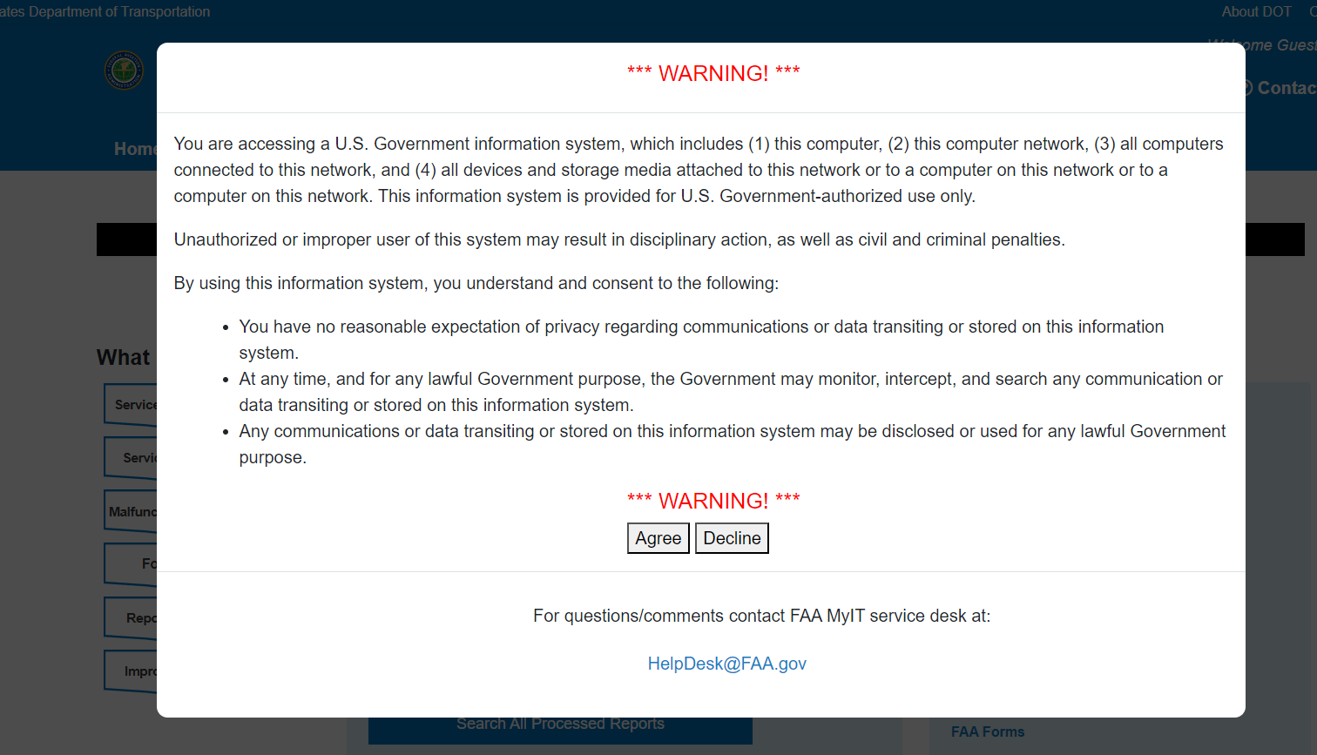

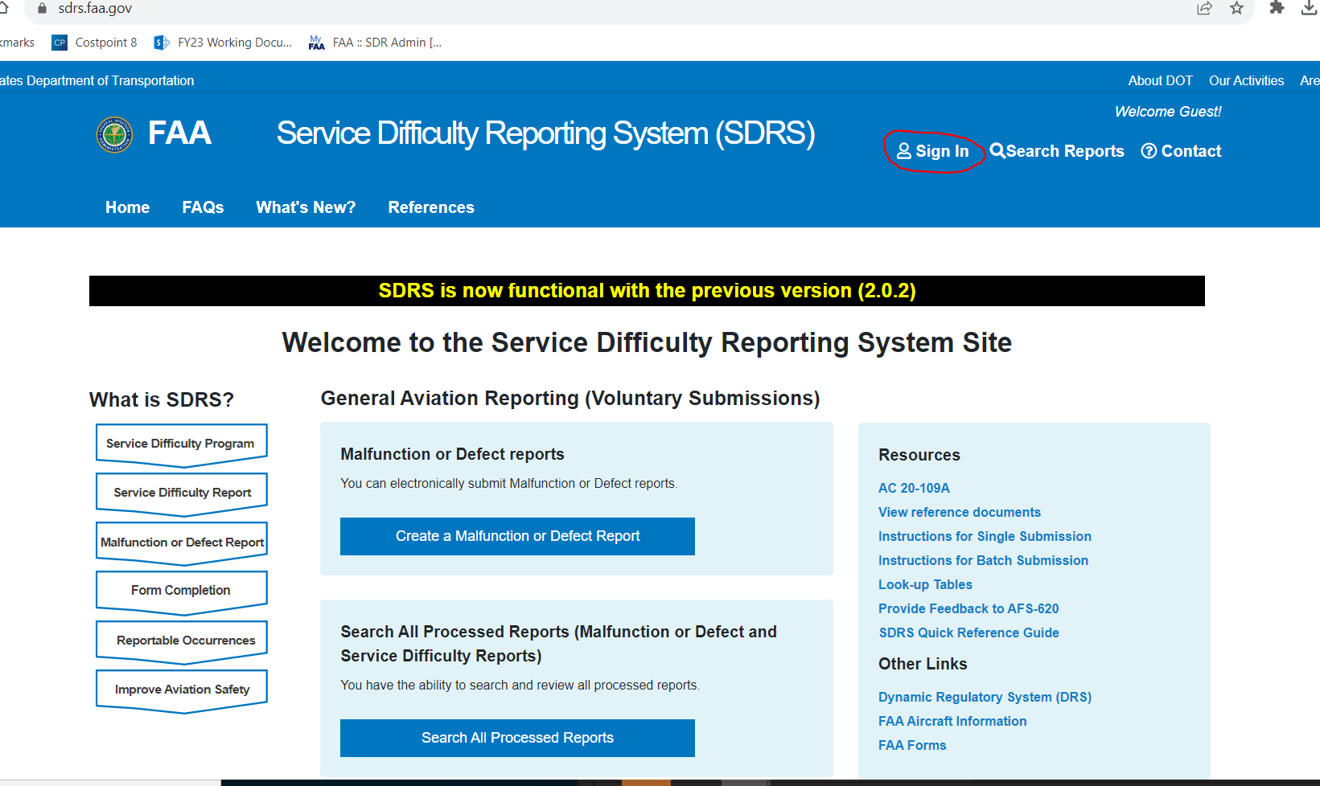

# Part 2: MFA for SDRS External Users (Submitters)

**This section captures three different scenarios for External Users on authenticating and using SDRS.**

* **Scenario 1**: New Users Not registered in OKTA and Not Authorized in SDRS (New Users)
* **Scenario 2**: Users registered in OKTA and authorized in SDRS, Accessing SDRS (Existing Users)
* **Scenario 3**: Existing SDRS Users, registering in OKTA and activating account and thereafter accessing SDRS

**Note:**

1. All Existing SDRS users must register in OKTA using their **existing email account** in SDRS and proceed to activate their account.
2. Users must Download the OKTA Verify or Google Authenticator prior to registering for OKTA

## **Scenario 2.1: New SDRS user not registered in OKTA and not authorized in SDRS.**

### **2.1.1 Accessing SDRS**

1. To access SDRS application, click on the SDRS URL <https://sdrs.faa.gov/> and click on “Agree” from the below screen.



1. On the SDRS Homepage click on **Sign In** 
2. MyAccess login screen will display.
3. As a new SDRS User, click on the **New User?** Register for an external account; highlighted in red.

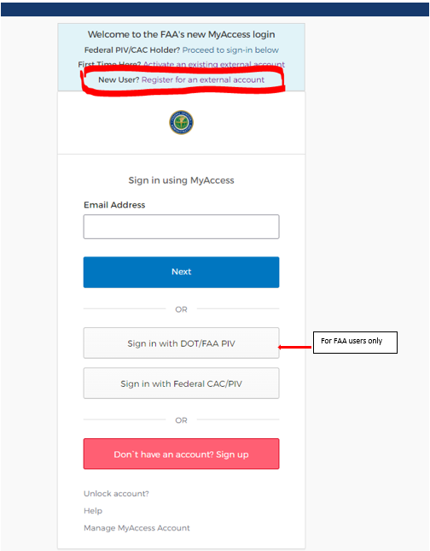

### **Registering in OKTA**

1. Enter your First Name, Last Name, Email Address, and select a method for identity verification.
   1. Last 4 Digits of you SSN or
   2. Capture Govt Issued ID document using mobile phone.
2. Check "I am not a robot" and click “**Submit**.”

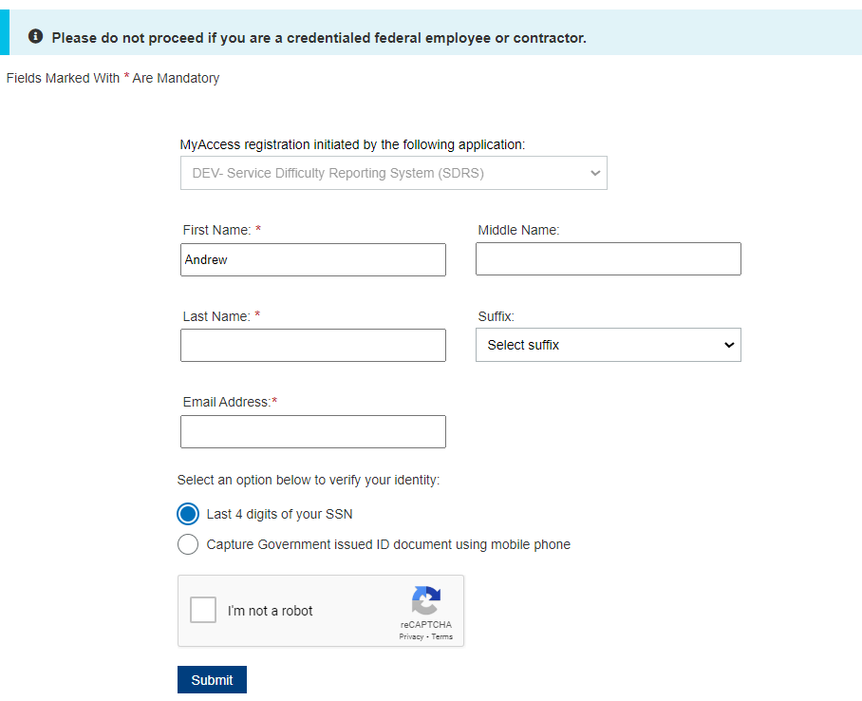

1. The **New User** will see the next screen to consent to provide personal information to continue for registration.

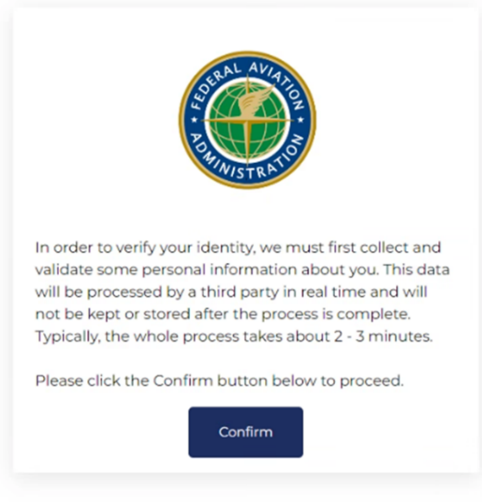

1. Clicking on the **confirm button** above will display the screen for the **New User** to fill in the required information for validating Identity. Select to receive a one-time password (OTP) on your mobile phone, as either a SMS or voice message. Click "Confirmation Information".

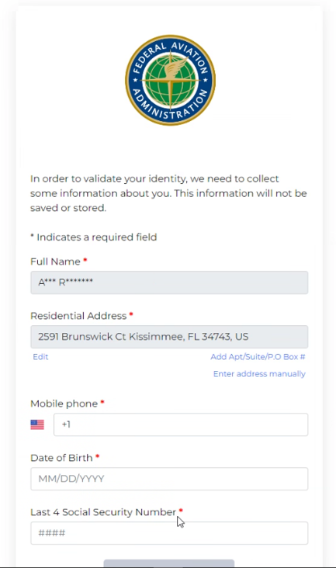

1. Enter the OTP sent to your mobile phone. Click "**Confirmation Information”**

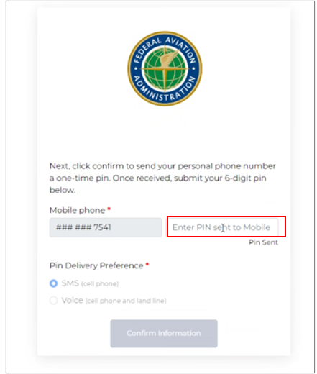

1. Upon successful submission, you (**User)** will receive:
   1. A web confirmation that the form was submitted successfully and
   2. will receive instructions in your email to activate account. 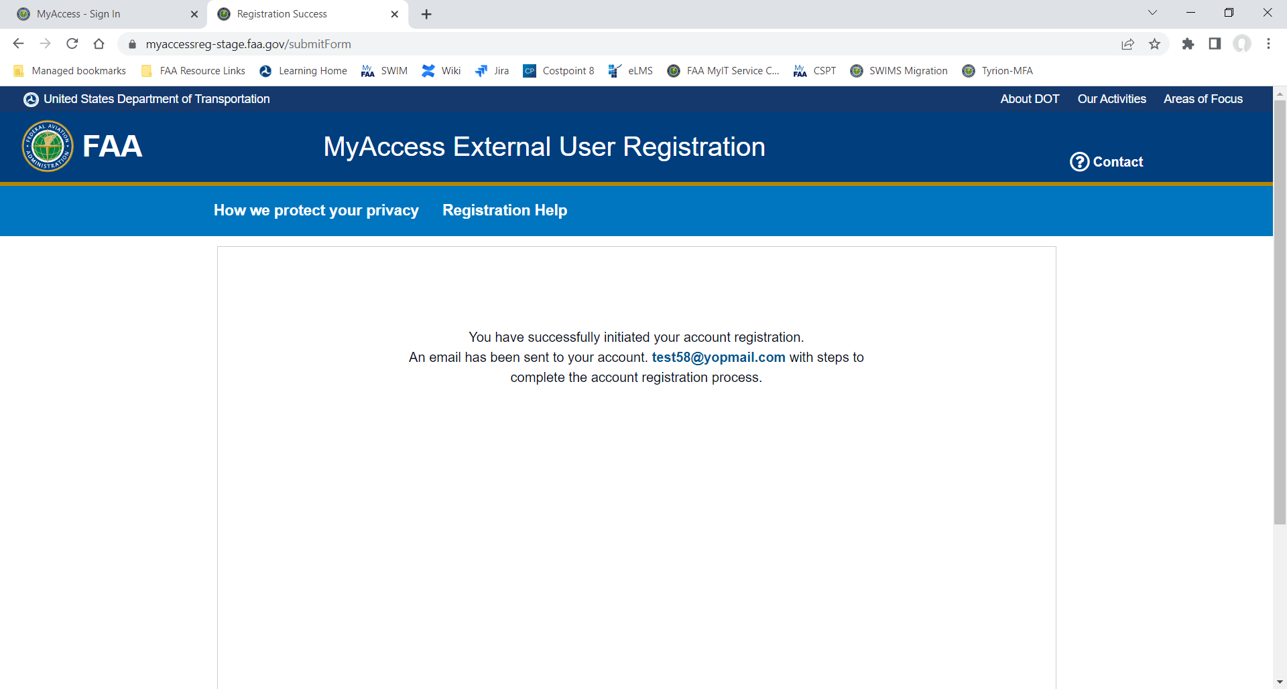

### **2.1.3 Activate OKTA Registration**

To **Activate MyAccess Account** the **New User** will access their email and view the message provided from OKTA to complete their new OKTA registration.

1. In the registration email, click on ‘**Activate my Access Account**’ link.

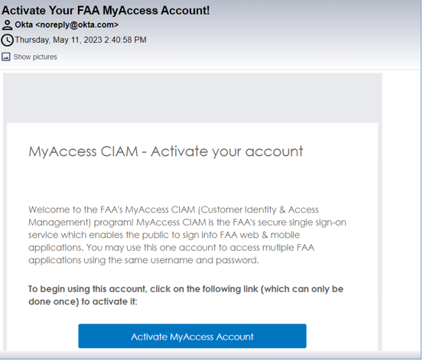

1. User will be redirected to the new user **OKTA set up** page. Click on the ‘**Set up’** button.

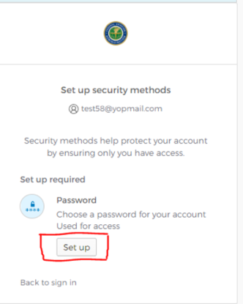

1. In the next screen, the **New user** will be directed to the OKTA password screen. Create a new password based on the OKTA password requirmentents and click the ‘**Next’** button.

**Note:** The authenicator should be installed on the user’s mobile device to proceed to the next steps.

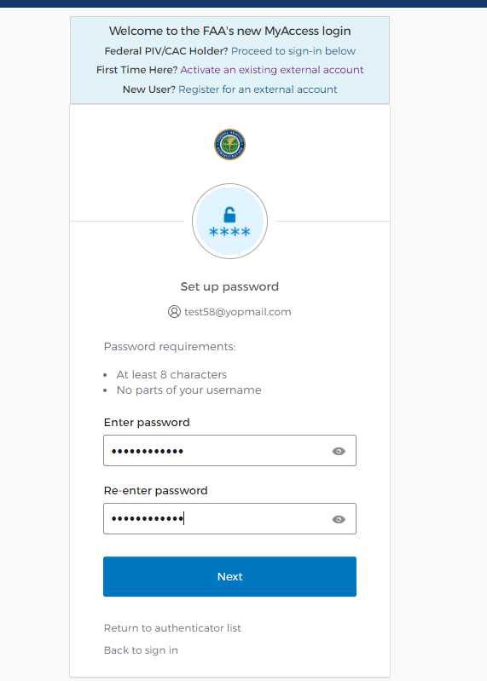

### **Setting up Authenticator.**

1. The **New user** will see the next screen for setting up security methods. The user can select one of the following set-up options and click **Set Up** button:
   1. **Google Authenticator**
   2. **OKTA Verify**
   3. **Security Key or Biometric Authenticator**

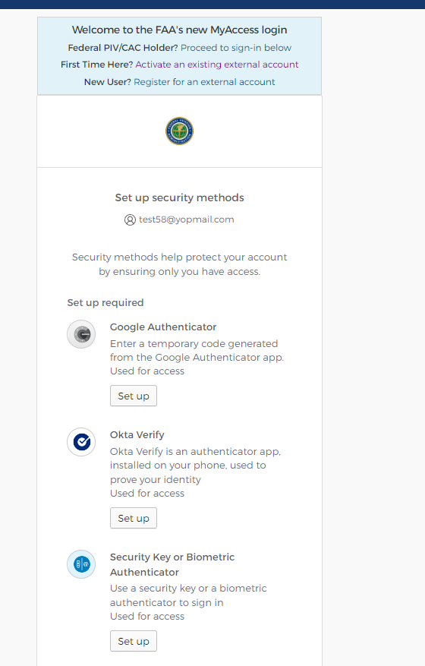

**Note:** To complete the security set up, the **New user** will need to **Install OKTA on their mobile device**.

### **Installing OKTA on your mobile device.**

1. **For iPhone Users**:
   1. Navigate to the app store and select:
      1. **Google Authenticator/OKTA Verify/Security Key or Biometric Authenticator**
   2. Download and install the app from the AppStore on the mobile device.

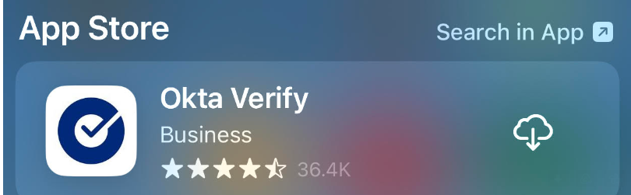

1. **For Android Phone Users:**
   1. Navigate to Google Play and select:
      1. **Google Authenticator/OKTA Verify/Security Key or Biometric Authenticator**
   2. Download and install the app from /Google play on the mobile device.

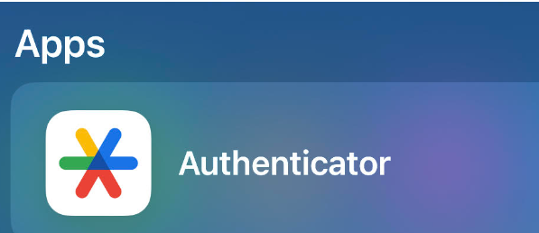

1. After downloading the app on the mobile device: follow these steps in sequence:
   1. Open Okta Verify/Google Authenticator/ Security Key or Biometric Authenticator and follow the instructions.
   2. Tap Add Account.
   3. Click on Organization.
   4. Click Yes, Ready to scan.
   5. Scan the QR code displayed on your computer in step XX by using camera.
   6. Click Done on Account added.
2. Once the setup is complete. Scan the QR code by using your mobile device’s camera. Click Done on Account added.

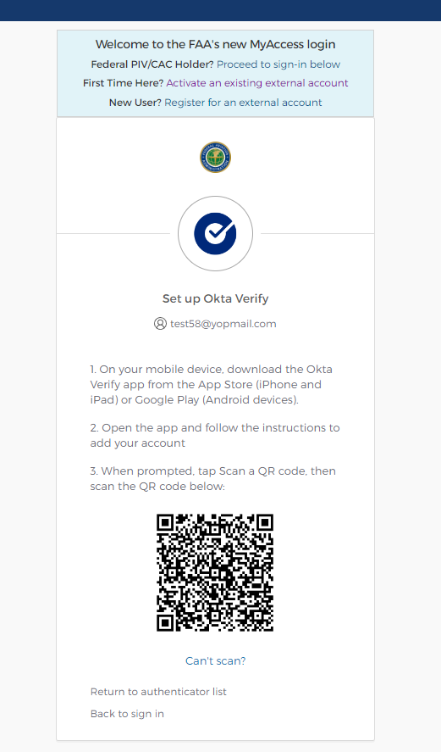

1. After scanning the bar code, the user will be directed to the following page. Please click on “Set Up Later”.

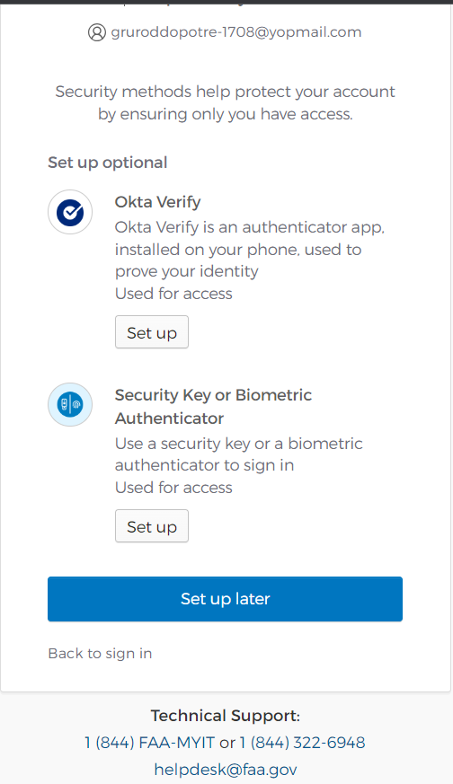

1. Once the mobile device and Authenticator are successfully paired, a ‘MyAccess account has been activated’ screen will be displayed on the computer. Two factor authentication for account access is set-up. And the user is successfully registered in OKTA.

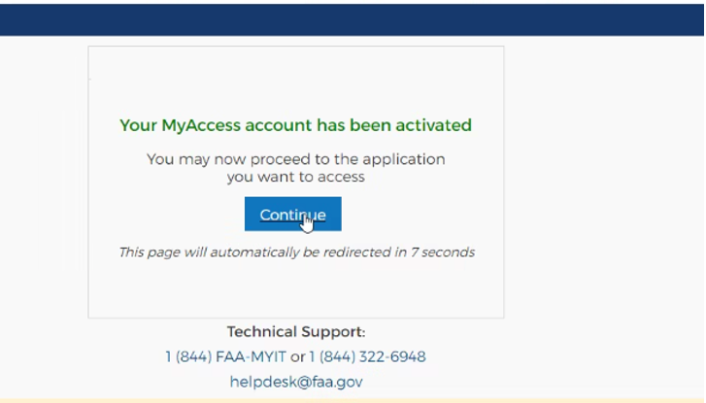

1. **Note**: Click on **Continue** to register to the SDRS application.

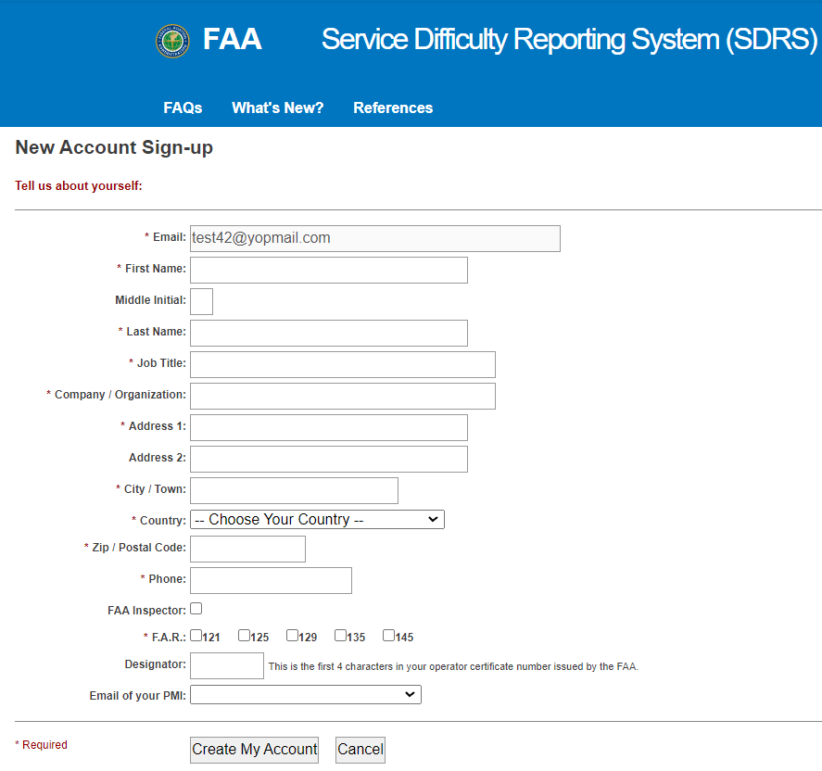

### **Registering in SDRS**

1. The user is redirected to the SDRS application to create a new account. Enter in all required credentials. Select the PMI designated to your account for approvals. Click create account.

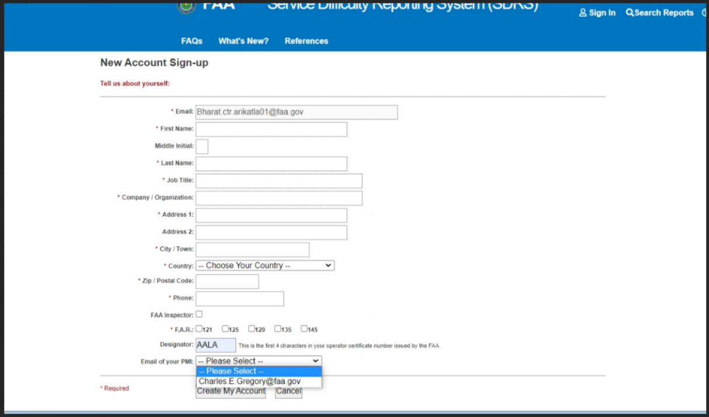

1. Upon submission the system will automatically send an email to PMI and SDRS admin (9-AMC-SDR-ProgMgr (FAA) [9-AMC-SDR-ProgMgr@faa.gov](mailto:9-AMC-SDR-ProgMgr@faa.gov))

### **Admin User Approving Account**

1. The SDRS admin will receive notification of the SDRS user account request and approves the request to authorize the user in SDRS.

**Note:** At this point, the ADMIN User will be able to verify the user is registered in OKTA, via a new interface.

1. On the User Account Management page, a new tab will be available OKTA Registered Users; the column “Exists in SDRS” has two flags:
2. True: Meaning the user is registered in OKTA and is authorized for access to SDRS and can access SDRS application
3. False: Meaning the user is registered in OKTA but is not authorized for access to SDRS and cannot access SDRS application.

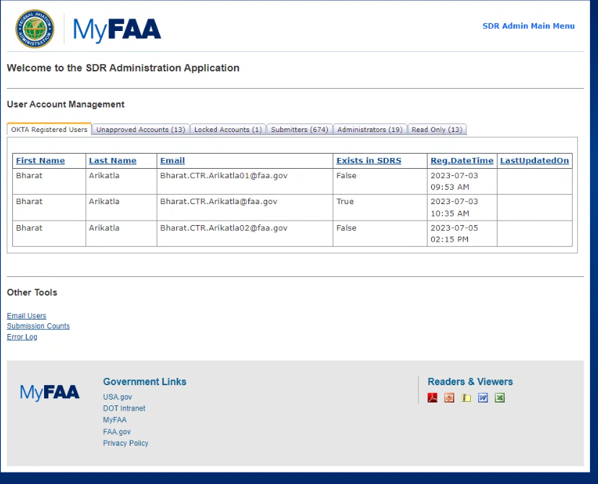

1. To set-up the User ADMIN will click on the user’s email, which is a hyperlink. You will be directed to the “Add New User” screen. Enter all required fields and click Save.

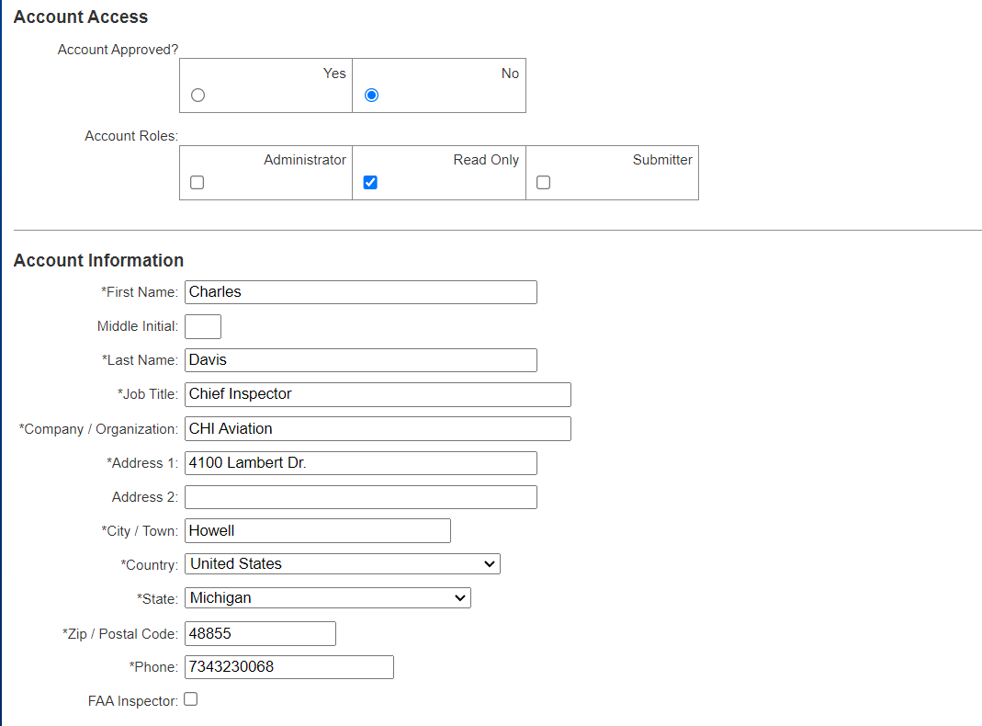

## **Scenario 2.2: User is authenticated in OKTA and registered in SDRS, accessing SDRS.**

### **Accessing SDRS**

1. Click on the SDRS URL <https://sdrs.faa.gov/> and click on “**Continue**” from the below screen:



1. On the SDRS Homepage click on **Sign In**



1. Navigate to the Login Page and enter **Email Address** and click Next button.

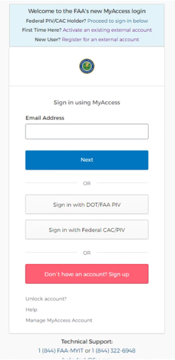

1. Enter Password and click Verify. You will see the Option to select your validation method.

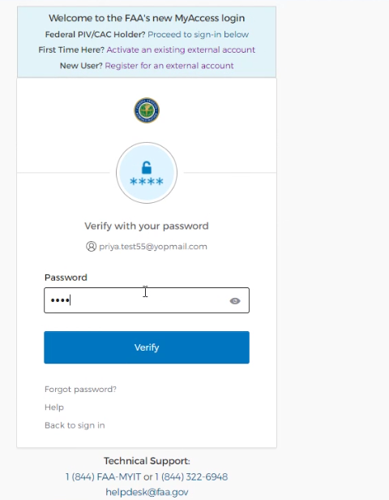

### **Validate using an authenticator.**

* 1. Select option to enter code.

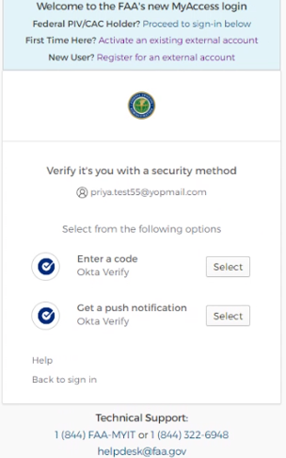

* 1. Enter the code from your mobile device. Depending on the app that the user download and the phone type, they will see the following options.
     1. If using Okta Verify, following code verification page will display.

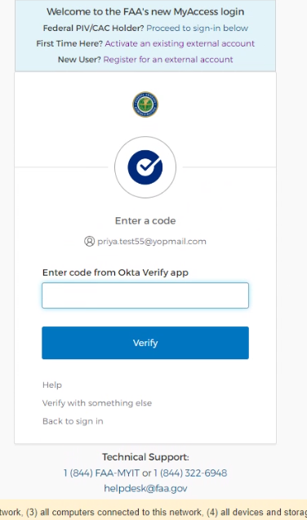

* + 1. If using Google Authenticator, following code verification page will display.

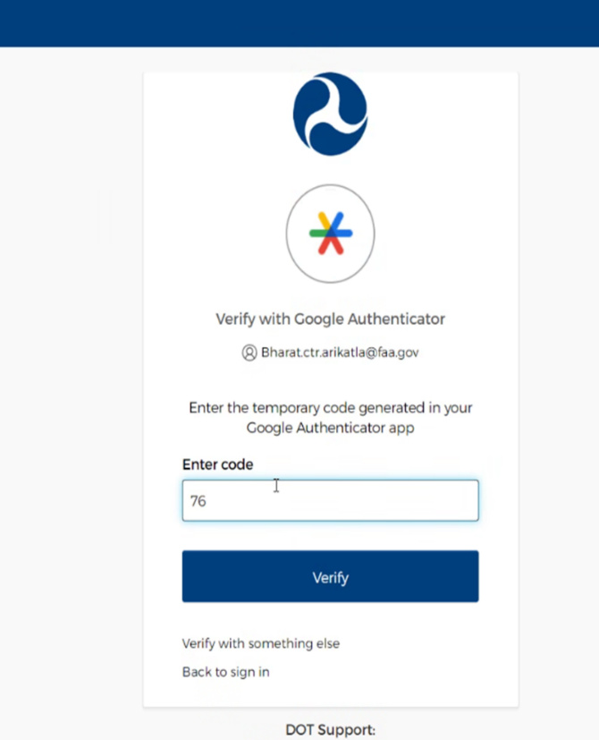

### **Landing Page view upon Validation**

1. Click verify and upon successful authentication the User will see the SDRS Landing Page:

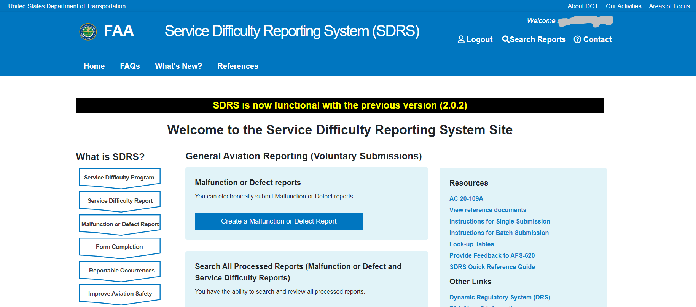

## **Scenario 2.3: Existing SDRS User Registering in OKTA and accessing SDRS**

### **Accessing SDRS**

1. Click on the SDRS URL <https://sdrs.faa.gov/> and click on “**Continue**” from the below screen:



1. On the SDRS Homepage click on **Sign In**



1. On the Sign in page, clickRegister for an external account link highlighted in red.



### **2.3.2 Registering in OKTA**

1. Enter your First Name, Last Name, **Email Address**, and select a method for identity verification.
   1. Last 4 Digits of your SSN or
   2. Capture Govt Issued ID document using mobile phone.
   3. **Note: It is important to use your existing SDRS email account to register for OKTA**
2. Check "I am not a robot" and click “**Submit**.”
3. The **User** will see the next screen to consent to provide personal information to continue for

registration.



1. Clicking on the **confirm button** above will display the screen for the **User** to fill in the required information for validating Identity. Select to receive a one-time password (OTP) on your mobile phone, as either a SMS or voice message. Click "Confirmation Information".



1. Enter the OTP sent to your mobile phone. Click "**Confirmation Information”**



1. Upon successful submission, you (**User)** will receive:
   1. A web confirmation that the form was submitted successfully and
   2. will receive instructions in your email to activate account.



### **2.3.3 Activate OKTA Registration**

To **Activate MyAccess Account** the **User** will access their email and view the message provided from OKTA to complete their new OKTA registration.

1. In the registration email, click on ‘**Activate my Access Account**’ link.



1. User will be redirected to the new user **OKTA set up** page. Click on the ‘**Set up’** button.



1. In the next screen, the **User** will be directed to the OKTA password screen. Create a new password based on the OKTA password requirmentents and click on the ‘**Next’** button.

**Note:** The authenicator should be installed on the **User’s** mobile device to proceed to the next steps.



### **Validating using Authenticator.**

1. The **User** will see the next screen for setting up security methods. The User can select one of the following set-up options and click **Set Up** button:
2. **Google Authenticator**
3. **OKTA Verify**
4. **Security Key or Biometric Authenticator** 
   1. E.G Select **OKTA Verify** and click Set up button.



1. Scan the QR code by using your mobile device’s camera. Click Done on Account added.



1. After scanning the bar code, the User will be directed to the following page. Please click on “Set Up Later”.



1. Once the mobile device and Authenticator are successfully paired, a ‘MyAccess account has been activated’ screen will be displayed on the computer. Two factor authentication for account access is set-up. And the User is successfully registered in OKTA.



1. Click on Continue. The SDRS Landing page will be displayed.



**Note:** it is likely that you may need to re-enter your credentials to sign in.

Click on sign in to access SDRS, and follow the steps in Scenario two (**Page 19** --

***Scenario 2.2: User is authenticated in OKTA and registered in SDRS, accessing SDRS)***